DESIGN GUIDELINES

Town of Portola Valley

These guidelines were developed under the direction of the Architectural and Site Control Commission, reviewed by the Planning Commission and approved by the Town Council on July 26, 1989.

Portola Valley Town Council

Ed Davis, Mayor Ted Driscoll, Vice Mayor
George Comstock Kirke Comstock
Richard Merk

Portola Valley Planning Commission

Craig Breon, Chair Arthur “Chip” McIntosh, Vice Chair
Linda Elkind Steve Toben
Leah Zaffaroni

Architectural and Site Control Commission

Carter Warr, Chair Laura Chase, Vice Chair
A.C. “Bud” Eisberg Steve Harrison

Mike Schilling

Prepared by

William Spangle and Associates, Inc.
City and Regional Planners
Thomas C. Vlasic, Project Director
Penelope A. Gregory, Project Planner including graphics and design

July 1989
(Revised September 2003, August 2006, and September 2013, July 2018)

CONTENTS

INTRODUCTION 1

SITE DESIGN 3

Grading 4

Vegetation Protection 5

View Preservation 6

Ridgelines/Hilltops 7

ARCHITECTURAL DESIGN 8

Scale/Context 9

Mass/Bulk 10

Accessory Structures 11

Entryways 12

Additional Design Concepts 13

Lighting 14

LANDSCAPE DESIGN 16

Planting Concepts 17

Plant Materials 18

APPENDICES 19

ASCC: Establishment and Purpose 20
Native Plant List/Discouraged List 21
Landscaping Guidelines 28
Satellite Antenna Guidelines 36
Story Poles – Requirements and Guidelines 38
What to Expect from Design Review 40

INTRODUCTION

The purpose of the Design Guidelines is to illustrate key design principles that the Architectural and Site Control Commission (ASCC) apply in evaluating applications for development of properties within the Town. This booklet is provided to familiarize applicants with site design, architectural design and landscape design concepts encouraged by the Town. Review and approval of applications by the ASCC is guided by these principles that are based on the regulations established in Chapter 18.64 (Zoning Ordinance) of the Municipal Code (see “ASCC: Establishment and Purpose” in the Appendices). The Town recommends strong consideration of the principles as they relate to individual application proposals.

A Major Goal of the Town is:

“To assure all building sites and residences are developed in a manner minimizing disturbance to natural terrain and vegetation, and maximizing preservation of natural beauty and open space.” (Portola Valley General Plan)

The Town of Portola Valley recognizes the value and importance of good design in achieving the goals set forth in the General Plan. Implementation of design criteria set forth in these Design Guidelines is intended to accomplish the following:

- Implement broad policies and goals set forth in the General Plan.
- Supplement design provisions established in the Zoning Ordinance in order to promote development that is in the best interests of the public health, safety and welfare of the Town.
- Establish criteria that will encourage good design and site relationships that are compatible with the natural features of the Town.

Other Major Community Goals:

“To Conserve the ‘rural’ quality of Portola Valley and maintain the Town as an attractive, tranquil family-oriented community …” (Portola Valley General Plan)

“Because the dominant features of the planning area are the natural land forms and vegetation, structures and land uses should be subordinated thereto …” (Portola Valley General Plan)

Each site in Portola Valley presents specific constraints to development and also presents unique opportunities. Careful site selection and design allows for sensitive development consistent with Town policies, while satisfying most individual needs. Not every site can accommodate two-story structures or accessory uses such as swimming pools, tennis courts, or stables. Each site must be approached individually with careful consideration given to site conditions early in the development stage. Good site development must begin with a thorough analysis of:

- Soils and geology
- Drainage and water features
- Topography
- Existing vegetation
- Views from the site
- Views from other properties to the site
- Design relationships to adjoining parcels and development

SITE DESIGN

To preserve and enhance the natural features of the Town through site development which is compatible with the physical constraints and natural features of the individual site and its surrounding area:

Grading
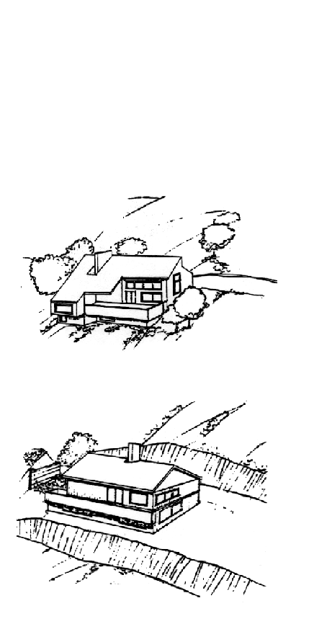

- Design structures to integrate with the natural topography of the site.

- Use contour grading to blend into landforms rather than severe cutting, filling, padding or terracing.

- Do not cross steep terrain to provide access to the building site.
This

- Design retaining walls as terraced or broken elements, not large single retaining walls.

- Control grading and site preparation to reduce erosion and soil exposure and minimize impacts on natural drainage systems.

- Revegetate cuts, fills, and other earth modification with appropriate native plant material.
Not This
Vegetation Preservation
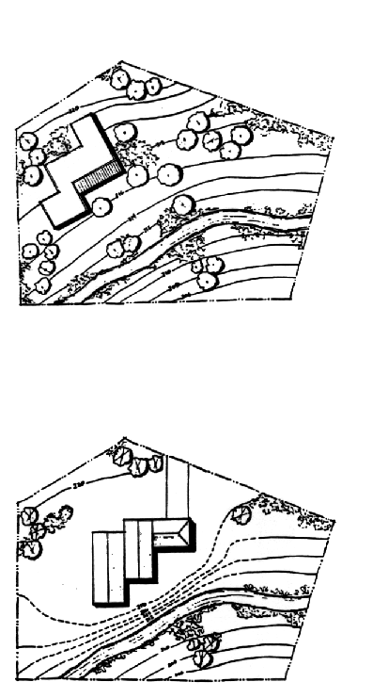

- Site structures, driveways and parking areas with respect to natural site conditions such as drainage systems and vegetation.

- Design structures around mature trees and integrate with existing vegetation.

This
- Remove only minimum vegetation necessary for grading and construction.

- Protect existing trees and vegetation during site preparation and construction.

Not This
View Preservation
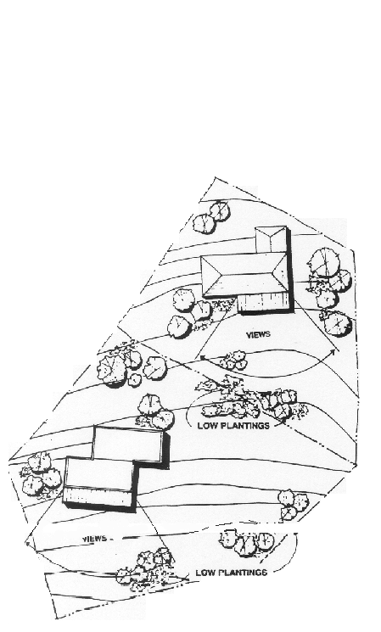

- Site structures to minimize adverse visual impacts when viewed from off the site. Do not locate structures in visually prominent locations.

- Maximize open space preservation.

- Protect view corridors on the site to maintain views of prominent scenic features.

- Prevent the obstruction of views of adjacent property owners by structures or additions to existing structures.

- Consider the future height of trees and shrubs so that you and your neighbors’ views on and off-site will not become obstructed.
Ridgelines/Hilltops

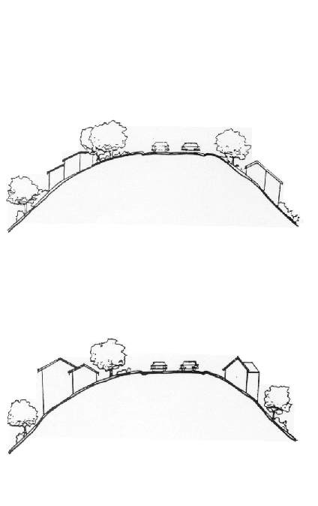

- Whenever possible, avoid siting structures on ridgelines and hilltops.

- Minimize removal of tree masses so as not to disrupt the natural silhouette.

- Minimize off-site visual impacts through use of natural colors and materials that blend with the natural environment.
This

- Keep rooflines of structures below the height of the existing tree canopy.

- Any construction on ridgelines should integrate with the natural context. Structures should be stepped with the hillsides and slopes of roofs should mirror slopes of the terrain.
Not This
ARCHITECTURAL DESIGN

To encourage architectural design that is:

- responsive to the site;
- in harmony with the natural environment;
- compatible with the surrounding neighborhood;
- in keeping with the rural character of the town.
Scale/Context

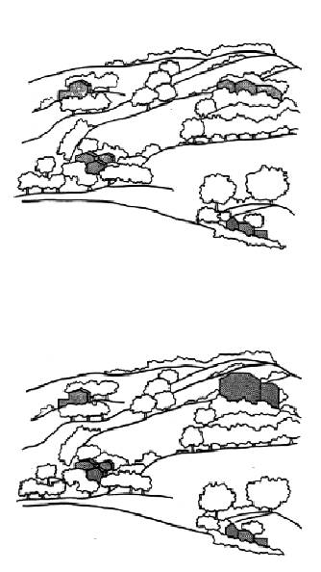
- Site and design structures with respect to the natural environment and the surrounding residential area.

- Design structures in proportion to the size and configuration of the lots on which they are placed.

- Structures should be sited and designed to be unobtrusive and subordinate to the landscape.
This

- In relating structures to the surrounding environment pay particular attention to shapes, colors and textures.

- Avoid architectural features that increase visual prominence.

Not This
Mass/Bulk
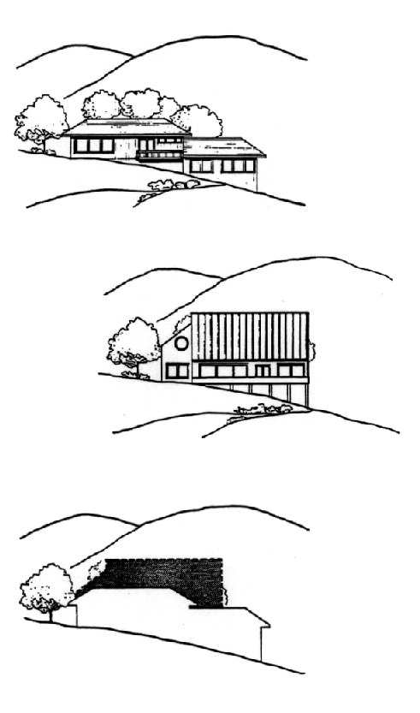

- On downhill slopes, avoid tall facades by stepping structures with the natural terrain.

This

- On downhill slopes, avoid cantilevered structures with tall supports and excessive roof overhangs.

- Reduce effective visible mass with the use of horizontal elements.
Not This

- Reduce the impacts of expansive facades by incorporating
- varied rooflines,
- offset facades,
- elements to produce shadow patterns.

Comparison
Accessory Structures

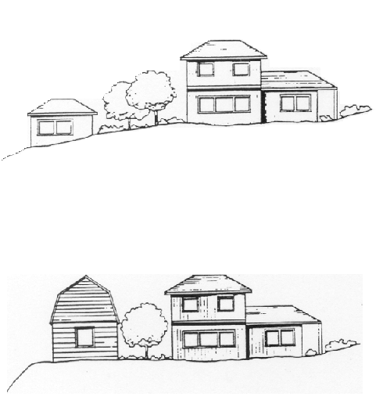
- Integrate accessory structures and additions with existing buildings by using similar forms, colors and materials.

- Integrate accessory structures with the natural terrain and vegetation of the site.
This

Not This
Entryways

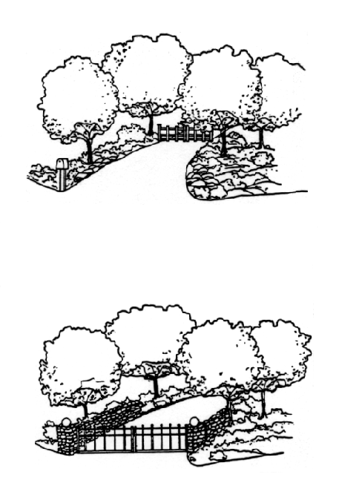
- Design entryways to blend with the natural environment.

- Reduce visibility and obtrusiveness of entryways by setting gates, pillars, etc. back from the roadway.

- Use indirect lighting at entryways to reduce off-site impacts.

This
- Structures, including light fixtures or other appurtenances, shall not exceed a height of 4 feet within front setbacks (Ord. 18.42.040.1).

- In zoning districts requiring a parcel area of 1 acre or more, the width of driveways in the front setback on a property should not exceed 12 feet unless a greater width is required for fire protection purposes, the setback is so small as to constrain access to a garage, or it has been demonstrated to the ASCC that for safety reasons a wider driveway is necessary.
Not This

Entryways

- Lighting of entryway features, including pillars and posts, are only permitted subject to prior approval by the ASCC. (Code Section, 18.42.018, B.)

- In zoning districts requiring 1 acre or more, entryway features, excluding mail boxes, shall be set back from the road right-of-way a distance of at least ½ of the required front yard. (Code Section 18.42.016, A.)

- Entryway features requiring a building permit are subject to approval by the ASCC. (Code 18.42.016, C.)
Additional Design Concepts

Colors and Materials
- Use colors and materials that blend with the natural environment.
- Do not use highly reflective colors and surfaces.
- Concrete driveways visible from off-site should be darkened to blend with the natural environment.
- For new construction and remodeling projects that come before the ASCC, colors shall be subject to ASCC approval. The reflectivity value for colors should not exceed 40%, except that the colors for trim should not have a reflectivity value over 50%.
- Homeowners and developers are encouraged to follow the above reflectivity values when repainting buildings.
- Light colored roofs are discouraged and in general should not exceed a reflectivity value of 40%, especially if visible from off site.

Additions
- Design additions to existing structures with careful consideration of the Town’s design objectives.
- Integrate additions to existing structures by using like materials, colors, forms and rooflines.

Fences and Gates
- Use low, open style fencing and gates to maintain the rural character of the Town.
- Reduce visibility of fences and gates by using colors and materials that blend with the natural environment.

Satellite Antennas
- Refer to the appendix “Satellite Antenna Guidelines.”
Lighting

- In order to maintain the rural character of Portola Valley, a minimal approach should be taken to outside illumination of any use, site, or structure within the town. Excessive lighting on an individual site (and/or the impact of cumulative lighting on adjoining sites) can create a glow that tends to obscure the night sky and stars, and results in a community that is more urban and less rural.

- Use only the minimum amount of lighting necessary to achieve essential illumination. The primary objective of exterior lighting should be safety for pedestrians and other non-vehicular uses around the primary building on the site. Lighting of front entries, main access doors, frequently used stairs, etc. may be appropriate, but should be determined on a case-by-case basis. Further, some lighting to identify address numbers and driveway entries may be acceptable, but should be considered only when it is determined that reflectors and reflective numbers cannot be used effectively.

- Natural site conditions and location should be taken into account in development of any plans for exterior lighting of a structure and/or property. Sites that have little tree cover and that are in very open and easily accessed locations should have less need for lighting than more secluded sites with heavy tree cover and difficult points of access. Further, in the development of all lighting plans, consideration should be given to maintaining the rural unlit character of the environment and to using natural lighting (e.g., moon light), lighting provided by vehicles entering a property and illumination passing through windows from inside a building.

- Exterior lighting should be located as close to building entries and key stair and accessways as possible.

- Lighting for purely decorative purposes should be avoided. For example, lighting around or within landscaped areas, accent lighting of architectural features, lighting of the perimeter parking and similar areas are discouraged. However, if landscape lighting is found necessary, for example, to light paths to a pool or deck or provide some light around such a feature that is used at night, low level recessed type lights should be used. Use of strip light type systems, such as multi-bulb step light strips, should be avoided. Up-lighting of landscaping or structures is prohibited (Code Section 18. 36.040). Occasional installation of fixtures not necessary for safety but that provide symmetry are allowed, so long as they are not wired for electricity (e.g. a light fixture on either side of a garage door).

- Lighting should be controlled, selected and adjusted so that lights are on only when needed. When motion sensors or other controls allow for a more limited use of lighting, they are preferred, especially to avoid lights being left on overnight. Motion triggered lighting should fade on and off after a brief time and should be limited to main and rear entry doors, and trash areas; they should not be used for general outdoor areas. Photocell and timer-controlled lighting should also include automatic shut-offs to avoid lights being left on throughout the night.

- Exterior light fixtures should be broken into groupings, each with their own control, such that lighting in one area can be on while all other lighting is off. Motion sensors should activate the minimum lighting necessary for security or safety purposes. At the same time, a master off-switch is encouraged.

- All light fixtures should be selected for their ability to focus light on the feature to be lighted (i.e., step, path, entry) and to have minimum light spillage. Fixtures designed to light large areas, conventional unshaded or non-recessed spot lights, or flood lights are prohibited. Lighting (including pool lights) should be directed inward, toward a property’s center, not outward beyond the property line.

- The source of light in any light fixture, i.e. the bulb or other source of indirect illumination, should not be visible off-site. Because homes in Portola Valley are located at multiple elevations, residents should select and place fixtures so that properties at a lower grade are minimally impacted by light visibility, direct or diffuse.

- Light color should be limited to the warmer spectrum of 2700-3500 Kelvins. Cooler-colored white and blue lights which disrupt nightlife and biological rhythms should not be used.

- When determining appropriate lumen output and spacing of outdoor lighting fixtures, the following chart, borrowed from the Portola Valley Ranch Design Guidelines, shall be used as a guide:

Fixture  Type | Max. Lumen  Output for a  Single Fixture | Maximum Lumen  Output for  Multiple Fixtures | Typical Installation
Overhead | 350 | 25 per linear foot walkway | Generally installed at entries  to carports or residences
Low-Height | 225 | 40 per linear foot of walkway  or deck/patio perimeter | Generally installed at  approximately every 4-8 feet
Stair-Step | 50 | 50 per 4 foot width of step | Generally installed on  the riser or underside of  every stair step

LANDSCAPE DESIGN

To preserve the qualities of the natural environment through the use of native plant materials and landscaping plans that provide a blended transition to adjacent open areas:

Planting Concepts

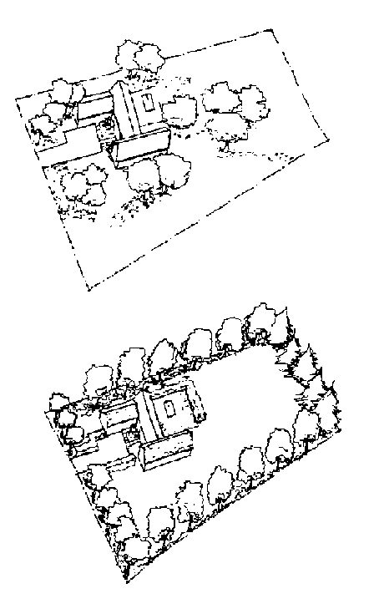
- Plant in random groupings to reflect the vegetation in adjacent properties and open space areas. Avoid linear plantings.

- Create a simple and natural design that blends with the site and area rather than an elaborate and formal landscape solution.

- Use a landscape plan to address conditions of the site such as controlling erosion, providing privacy, creating shade and softening the appearance of structures.
This

- Planting in trail easements or conservation easements is prohibited.

- Avoid plantings that would restrict sight distance, require unusual maintenance or interfere with already established indigenous plantings in areas adjacent to street rights-of-way and trail easements

- For additional guidance, see appendix “Landscape Guidelines”.
Not This
Plant Materials

NATIVE PLANT MATERIALS

(Refer to appendix “Native Plant List” for a complete selection with descriptions.)

Native Trees

Coast Live Oak
Black Oak
Valley Oak
Coast Redwood
Douglas Fir
California Bay Laurel
Big Leaf Maple
Madrone
Wild Cherry
California Buckeye

Native Shrubs

Manzanita
California Wild Lilac
Common Flannel Bush
Silk Tassel Bush
Christmas Berry
Coffeeberry
- Use native plants, except on private viewed areas on the site. Carefully select native plants for areas along property boundaries or in corridors viewed from off-site.

- Indigenous plants require less irrigation and maintenance.

- Do not replace existing plant materials with incompatible plant materials that would alter the character of the landscape.

- Use plants that are appropriate for “sub-environments” (such as open grasslands or oak forests) that exist within the Town.

APPENDICES

ASCC: Establishment
and Purpose

Architectural and site plan review of specified structures is established in Chapter 18.74 of the Municipal Code. The code establishes a five member Architectural and Site Control Commission (ASCC) to review plans. As stated in Section 18.64,010,

“the purpose of architectural and site plan review and approval is to promote the preservation of the visual character of Portola Valley, the stability of land values and investments, the public safety, and the general welfare by preventing the erection of structures or additions or alterations thereto of unsightly or obnoxious appearance or which are not properly related to their sites, adjacent uses, and circulation in the vicinity, and by preventing the indiscriminate clearing of property, excessive grading and the destruction of trees and shrubbery.”

Native Plant List

The first section (Part I) of the following list describes trees, shrubs, ground covers, perennials, bulbs, and annuals that are indigenous to (living naturally in) Portola Valley. Therefore, not only for their beauty and contribution to the rural aspect of the valley, but also because they are among those most likely to thrive with the least care, they are highly recommended choices for use here.

A supplemental list (Part II) follows the first and contains plants that, while not indigenous to Portola Valley, are native to other parts of California and will perform well here.

The Strongly Discouraged list highlights plants that are not appropriate for use in Portola Valley as they are non-natives, have been introduced here, and have adapted so well as to crowd out the natives, presenting a real threat to the local plant community. These plants should be avoided.

These lists are intended for use in conjunction with the Town’s approved landscape guidelines (also included in the appendices) that provide additional insight and guidance into appropriate plantings for particular locales.
Native & Supplemental
Plant List

Latin Name | Common Name | Habitat | Maximum Height
 |  |  | Meters | Feet
Part I: Plants Native to Portola Valley Area
TREES
Acer macrophyllum | Big Leaf Maple | Riparian | 30 | 98
Aesculus californica | California Buckeye | Riparian, cool north slopes, woodland | 12 | 39
Alnus rhombifolia | White Alder | Riparian | 35 | 115
Arbutus menziesii | Madrone | Upland | 40 | 131
Notholithocarpus densiflorus | Tanbark or Tan Oak | Upland, woodland | 30 | 98
Prunus ilicifolia | Holly-Leafed Cherry | Open woodland, chaparral | 5 | 16
Pseudotsuga menziesii | Douglas Fir | Upland | 44 | 144
Quercus agrifolia | Coast Live Oak | Upland | 25 | 82
Quercus chrysolepis | Canyon Live Oak | Upland | 20 | 66
Quercus douglasii | Blue Oak | Upland, woodland, must be summer dry | 20 | 66
Quercus kelloggii | Black Oak | Upland | 24 | 79
Quercus lobata | Valley Oak | Riparian, deep soil | 35 | 115
Sequoia sempervirens | Coast Redwood | Riparian, fog drip | 115 | 377
Umbellularia californica | California Bay Laurel | Upland, seeps and springs | 45 | 148
SHRUBS
Adenostoma fasciculatum | Chamise | Chaparral | 4 | 13
Arctostaphylos spp., incl hybrids | Manzanita | Upland, well drained | 8 | 26
Artemisia californica | Coast or California Sagebrush | Chaparral | 1.5 | 5
Ceanothus spp., incl hybrids | California Wild Lilac | Upland, scrubland | 3 | 10
Corylus cornuta variety californica | California Hazelnut | Scrubland, woodland, riparian | 4 | 13
Fremontodendron californicum | Common Flannel Bush | Well drained | 8 | 26
Garrya elliptica | Silk Tassel Bush | Open woodland, scrubland | 8 | 26
Heteromeles arbutifloria | Toyon, Christmas Berry | Woodland, forest edge scrubland | 5 | 16
Holodiscus discolor | Cream Bush, Oceanspray | Woodland, seeps and springs | 6 | 20
Lepechinia calycina | White Pitcher Sage | Upland, woodland, scrubland | 1.5 | 5
Mimulus aurantiacus | Bush Monkey Flower | Scrubland, chaparral | 1.5 | 5
Physocarpus capitatus | Ninebark | Riparian, woodland | 0.5 | 2
Quercus durata | Leather Oak | Serpentine scrubland | 3 | 10
Frangula californica | Coffeeberry | Scrubland, woodland | 5 | 16
Rhamnus crocea | Redberry | Open woodland, moist slopes, scrubland | 2 | 7
Ribes malvaceum | Chaparral Currant | Woodland, chaparral | 2 | 7
Latin Name | Common Name | Habitat | Maximum Height
 |  |  | Meters | Feet
Ribes speciosum | Fuchsia-flowered Gooseberry | Scrubland, chapparl | 2 | 7
Rosa californica | California Wild Rose | Woodland | 2 | 7
Rosa gymnocarpa | Wood Rose | Woodland | 1.5 | 5
Rosa spithamea | Common Rose | Chaparral, Oak Woodland | 0.5 | 2
Vaccinium ovatum | Evergreen Huckleberry | Scrubland | 3 | 10
GROUND COVERS/LAWN SUBSTITUTES
Achillea millefolium | Yarrow | Scrubland, chaparral, grassland | 0.5 | 2
Danthonia californica | California Oat Grass | Riparian, moist slopes | 0.25 | 1
Festuca californica | California Fescue | Woodland, chaparral | 1.3 | 4
Festuca rubra | Red Fescue | Woodland, chaparral, grassland | 0.25 | 1
Fragaria vesca | Woodland Strawberry | Woodland | 0.25 | 1
Stipa lepida | Foothill Needlegrass | Woodland, chaparral, scrubland | 0.8 | 3
Stipa pulchra | Purple Needlegrass | Scrubland, grassland | 0.8 | 3
PERENNIALS
Anaphalis margaritacea | California Everlasting | Upland sun
Aquilegia Formosa | Crimson Columbine | Woodland
Cynoglossum grande | Hound’s Tongue | Woodland
Epilobium canum | California Fuchsia | Well drained, sun
Eriophyllum confertiflorum | Golden Yarrow | Well drained, sun
Heterotheca sessiliflora | Golden Aster | Well drained
Heuchera microntha | Smallflower Alumroot | Woodland, shady
Iris douglasiana | Douglas Iris | Woodland, shade to sun
Iris fernaldii | Fernald’s Iris | Woodland, shade to sun
Iris longipetala | Long Petaled Iris | Woodland, shade to sun
Lupinus albifrans | Silver Bush Lupine | Upland, chaparral
Penstemon heterophyllus | Chaparral Penstemon | Scrubland, chaparral
Ranunculus californicus | California Buttercup | Seeps, moist meadows
Salvia spathacea | Hummingbird Sage | Grassland
Sidalcea malvaeflora | Checkerbloom | Sun
Silene californica | California Indian Pink | Grassland
Sisyrinchium bellum | Blue-Eyed Grass | Sun, grassland
Solanum umbelliferum | Blue Witch | Scrubland, chaparral
Stachys bullata | California Hedge Nettle | Woodland, moist areas
Tellima grandiflora | Fringe Cup | Seeps, moist shade
Wyethia glabra | Mule Ears | Grassland
BULBS
Brodiaea elegans | Elegant Brodiaea | Scrubland, semi-shade
Brodiaea terrestris | Dwarf Brodiaea | Grassland, serpentine
Calochortus albus | Fairy Lanterns | Grassland, slopes
Calochortus argillosa | Clay Mariposa Lily | Grassland, slopes
Calochortus luteus | Yellow Mariposa Lily | Grassland, slopes
Chlorogalum pomeridianum | Soap Plant | Scrubland, Grassland
Clintonia andrewsiana | Red Bead Lily | Woodland, shade
Dodecatheon clevelandii | Lowland Shooting Star | Grassland, sun to shade
Latin Name | Common Name | Habitat | Maximum Height
 |  |  | Meters | Feet
Dodecatheon hendersonii | Shooting Star | Grassland, sun to shade
Fritillaria lanceolata | Mission Bells, Checker Lily | Woodland, shade
Lilium pardalinum | Leopard Lily, Tiger Lily | Woodland, shade
ANNUALS, WILD FLOWERS
Aster chilensis | Common California Aster | Grassland, dry slopes
Clarkia purpurea | Four Spot | Grassland
Clarkia rubicunda | Farewell-to-Spring | Grassland, serpentine
Clarkia unguiculata | Elegant Clarkia | Grassland, dry slopes
Collinsia heterophylla | Chinese Houses | Woodland, shade
Eschscholzia californica | Poppy | Scrubland, Grassland
Gilia tricolor | Tricolor Gilia | Scrubland, Grassland
Lasthenia glabrata | Goldfields | Grassland, serpentine
Layia platyglossa | Tidy Tips | Grassland
Limnanthes douglasii | Meadowfoam | Grassland, sun
Leptosiphon androsaceus | Common Linanthus | Grassland
Leptosiphon grandiflorus | Mountain Phlox | Grassland, serpentine
Leptosiphon parviflorus | Small Flowered Linanthus | Grassland, serpentine
Linum lewisii | Western Blue Flax | Upland, sun
Lupinus spp. | Lupine, various | Scrubland, Grassland
Monardella villosa | Coyote Mint | Upland sun to shade
Nemophila menziesii | Baby Blue Eyes | Scrubland
Orthocarpus densiflora | Owl’s Clover | Grassland, sun
Orthocarpus purpurascens | Purple Owl’s Clover | Grassland, sun
Phacelia spp. | Phacelia | Well-drained
Thalictrum fendleri | Meadow Rue | Woodland
Latin Name | Common Name | Habitat | Maximum Height
 |  |  | Meters | Feet
Part II: Plants Native to California, not found in Portola Valley naturally
TREES
Cornus nuttallii | Western Dogwood, Pacific Dogwood | Woodland | 25 | 82
Fremontodendron – all species | Flannel Bush | Chaparral | 8 | 26
Lyonothamnus floribundus | Catalina Ironwood | Chaparral, woodland | 12 | 40
Morella californica | Pacific Wax Myrtle | Riparian, seeps and springs | 10 | 33
Platanus racemosa | California Sycamore | Riparian | 35 | 115
Prunus lyoni | Catalina Cherry | Chaparral, woodland | 35 | 115
SHRUBS
Acer circinatum | Vine Maple | Upland | 6 | 20
Calycanthus occidentalis | Spice Bush | Woodland | 3 | 10
Carpenteria californica | Bush Anemone | Scrubland | 3 | 10
Cercis occidentalis | Western Redbud | Riparian | 7 | 23
Comarostaphylis diversifolia var. planifolia | Summer Holly | Chaparral | 5 | 16
Dendromecon harfordii | Island Bush Poppy | Scrubland, well drained slopes | 6 | 20
Dendromecon rigida | Bush Poppy | Scrubland, well drained slopes | 3 | 10
Eriogonum fasciculatum | California Buckwheat | Scrubland | 2 | 7
Berberis aquifolium | Oregon Grape | Woodland | 2 | 7
Berberis pinnata | California Holly Grape | Woodland, scrubland | 0.8 | 3
Rhododendron macrophyllum | Coast Rhododendron | Moist, conifer forests, acid soils | 4 | 13
Rhododendron occidentale | Western Azalea | Riparian, seeps and springs, acid soils | 3.5 | 11
Rhus integrifolia | Lemonade Berry | Upland, scrubland | 8 | 26
Rhus ovata | Sugar Bush | Upland, scrubland | 10 | 33
Romneya coulteri | Matilija Poppy | Dry, gravel soils, well drained | 2.5 | 8
GROUND COVERS/LAWN SUBSTITUTES
Arctostaphylos, low growing species | Manzanita | Chaparral | 0.25 | 1
Baccharis pilularis | Dwarf Coyote Bush | Scrubland | 0.8 | 3
Carex pansa | Dune Sedge | Riparian, woodland | 0.25 | 1
Ceanothus, low growing species | California Wild Lilac | Woodland edge, upland to chaparral | 1.2 | 4
PERENNIALS
Armeria maritima | Sea Pink | Well drained
Galvezia speciosa | Island Snapdragon | Well drained, rocky soils, open areas
Oenothera hookeri | Evening Primrose | Meadows, moist
Penstemon newberryi | Mountain Pride | Scrubland, sun
Penstemon palmeri | Palmer’s Penstemon | Scrubland, sun
Habitat Key
HABITAT | PREFERRED GARDEN CONDITIONS
Chaparral | Full sun, dry, well drained
Riparian | Near creeks or deep watering in summer
Scrubland | Full sun, dry, less well drained, some summer water okay
Seeps and springs | Constant moisture, do not let dry out in summer
Upland | Full sun, dry
Well drained | Cannot tolerate wet conditions in summer
Woodland | Part sun to shade, but relatively dry
Heights are maximum sizes, most plants will top out some 20% to 30% shorter

Strongly Discouraged

These plants are incompatible with Portola Valley indigenous plant materials and will crowd them out. Do not plant them. *Identified as highly flammable by the Woodside Fire Protection District. Last update: 10/16

TREES
Ailanthus altissimo | TREE OF HEAVEN
Acacia baileyana | BAILEY ACACIA *
Acacia decurrens | GREEN WATTLE *
Acacia melanoxylon | BLACKWOOD ACACIA *
Phoenix canariensis | CANARY PALM *
Cedrus deodara | DEODAR CEDAR
Cedrus atlantica | ATLAS CEDAR
Phoenix dactylifera | DATE PALM *
Eucalyptus globules | BLUE GUM (EUCALYPTUS) *
Eucalyptus globules “compacta” | DWARF BLUE GUM (EUCALYPTUS) *
Pinus radiata | MONTEREY PINE *
Populus alba | WHITE POPLAR
Olea europea | OLIVE FERTILE & INFERTILE
Schinus molle | PEPPER TREE
Washingtonia robusta | MEXICAN FAN PALM *
SHRUBS
Cortarderia selloana , jubata | PAMPAS GRASS *
Pennisetum sp. | FOUNTAIN GRASS *
Cotoneaster lacteal | RED CLUSTERBERRY
Cotoneaster salicifolia | WILLOWLEAF COTONEASTER
Cytisus canariensis | CANARY ISLAND BROOM *
Cytisus racemosus | EASTER BROOM *
Cytisus scoparius | SCOTCH BROOM *
Genista hispanica | SPANISH BROOM *
Genista monspessulanum | FRENCH BROOM *
Spartium junceum | SPANISH OR WEAVERS’ BROOM *
Cytisus spachianus | SWEET BROOM
Pyracantha spp. | FIRETHORN
GROUND COVERS
Hedera canariensis | ALGERIAN IVY
Hedera helix | ENGLISH IVY
Vinca major | PERIWINKLE
Vinca minor | DWARF PERIWINKLE
Hypericum calycinum | AARON’S BEARD, CREEPING ST. JOHN’S WORT
Nassella tenuissima | MEXICAN FEATHER GRASS *
Carex tumulicola | BERKELEY SEDGE
Carex divulsa | EUROPEAN GRAY SEDGE/BERKELEY SEDGE
Arctotheca calendula | CAPE WEED

Landscaping
Guidelines

Introduction and Purpose

Landscaping is an important element of all land development within the Town of Portola Valley. The Town General Plan and ordinances contain general statements of policy for landscaping within the Town. These policies emphasize preservation of the natural environment as exemplified in the following General Plan objective:

“To assure that all building sites and residences are developed in a manner minimizing disturbance to natural terrain and vegetation and maximizing preservation of natural beauty and open space.”

The purpose of the “Landscaping Guidelines” is to supplement statements in the General Plan and ordinances by providing more specific guidance regarding landscaping of individual residential sites, as well as other land development projects within the Town.

Landscaping Plan Review Procedures

Town ordinances require review of all development plans for new residences and for grading associated with new residences, residential additions or other land development. The zoning and site development regulations contain general landscape plan provisions. The Architectural and Site Control Commission (ASCC) has primary responsibility for review of landscape plans for conformance with Town policies and regulations. The main objective of the ASCC is to minimize off-site impacts of development. THE FUNDAMENTAL APPROACH OF THE ASCC IS TO ENCOURAGE ARCHITECTURAL SOLUTIONS THAT BLEND WITH THE NATURAL CONDITIONS OF THE SITE AND AREA, AND AT THE SAME TIME REQUIRE ONLY MINIMUM LANDSCAPING.

Guidelines for Landscaping

- Use native plants, particularly along property boundaries or in corridors viewed from nearby properties. Select plants from the Town’s native plant list.

- Use a landscape plan to address the particular needs of the property such as controlling erosion, providing privacy, creating shade, and softening or mitigating the appearance of structures.

- Create a SIMPLE rather than an elaborate landscape solution.

- Make use of existing plant material, especially indigenous grasses, chaparral and oaks. Do not replace with incompatible plant materials. Refer to the Town’s Native Plant List.

- Plant in random groupings (cluster planting) rather than in linear form. Allow plants and shrubs to appear to flow across property lines. Avoid a cultivated, formal appearance.

- Whenever possible, leave large areas in grasses and other indigenous plants.

- Use appropriate plant material in each location such as Alders and Redwoods in damp, shady locations and Oaks in dry, open areas.

- Consider the future height of trees and shrubs such that major views on- and off-site will not become obstructed.

- Avoid the introduction of non-indigenous trees that would dramatically alter the character of the landscape.

- Planting in trail easements or conservation easements if prohibited.

- Adjacent to street rights-of-way or trail easements avoid plantings that would restrict sight distance, require unusual maintenance to keep easements open, or interfere with already established indigenous plantings.

Landscaping Guidelines adopted by the Town of Portola Valley on April 22, 1986.
Redwood
Guidelines

Introduction and Purpose
The Conservation Committee strives to protect heritage and significant sized trees that are growing in appropriate natural habitats where they thrive without human intervention.
Sequoia sempervirens, or Coast Redwoods, are iconic California native plants that are among the tallest and longest living of all trees. These trees once covered 1.6 million acres of California in 1850, but now more than 95% of the old growth forest is gone, lost to indiscriminate logging, especially during the gold rush. Redwoods are admirable trees that are familiar in the Portola Valley landscape and we are fortunate that this unique tree can thrive in our community. Like most native plants, redwoods thrive naturally in habitats that are appropriate to their needs. Specifically, they need both summer and winter fog and adequate rainfall, which occurs in a narrow coastal belt between the 42nd and 36th degree North latitudes. Portola Valley is at 37.3 degrees North.
Humans can alter habitats in such ways as to allow almost any plant to grow, even if that species would not normally be found in that location. Since redwoods require a constant supply of water in the summer, they do not grow naturally in the oak woodlands and other dry land communities in the hills on the bay side of our valley where fog drip is not as common. Redwoods can only stay healthy and alive in those habitats with the human intervention of summer watering.
The purpose of these guidelines is to provide current and future homeowners with information on where it is appropriate to plant redwoods on their property and the process for removing them if they currently exist.

I. Planting of Redwoods

A. Grouping of Trees
This species has a preference for the company of other close redwoods. When grown as a stand-alone tree, they are prone to topple in a windstorm because they have no taproot. Planting the trees in clusters allows their root systems to become intertwined, providing the support needed to survive major windstorms that frequent the central and northern sections of the California coastline. Therefore, if one is interested in planting a redwood in a suitable location, several of them should be grouped together or closely spaced, as anyone who ever walked into an old growth native forest has observed.

B. Appropriate Planting Locations
Among the habitats where redwoods would be appropriate to be planted, are the following locations that provide a year round source of water:
      - Along perennial streams in riparian areas.
      - In fog drip locations along the western hillsides. The latitudinal limits of coast redwood distribution correspond approximately to the 35% fog threshold.
      - In sag ponds and large seep areas.
      - In high water table areas, where the water is so near the surface that no supplemental water is needed.
      - Far enough from existing or proposed structures that their extensive root systems will not cause damage.

C. Inappropriate Planting Locations
The Conservation Committee discourages the planting of redwoods in locations outside of their native microclimate. This recommendation is consistent with low water usage and appropriate natural vegetation communities policies that the Town and the Conservation Committee encourage. In addition, the insatiable appetite for water, particularly from fog drip, has resulted in redwoods developing a shallow and very extensive lateral root system which can extend 100 feet from the trunk in a mature tree (a mature redwood can consume 500 gallons of water a day). This root system often causes problems with the foundations of nearby buildings, septic tanks and leach fields. Furthermore, redwoods can grow rapidly, and unless carefully sited, can block views causing strife between neighbors.
Based on these characteristics, the Committee discourages the planting of redwoods in the following locations:
      - Oak woodlands.
      - Grasslands and meadows.
      - Anywhere that requires supplemental summer watering.
      - Within 50 feet of any existing or proposed structures, septic systems or leach fields where the roots will eventually cause problems.
      - In any locations where eventual growth will compromise your view or your neighbor’s view.
      - For screening, unless careful consideration has been given to eventual height and view obstruction for you or your neighbors. There are more appropriate plantings to choose for screening, such as Holly Leaf Cherry. See the attached Appendix A or the Town website for more appropriate screening shrubs and trees. It is never appropriate to create a hedge of any plant.

II. Care of Redwoods

A redwood growing in an appropriate habitat needs no special care once it is established. The trees are native to the area and resistant to fungus and parasites. The trees should never be topped.

III. Removal of Existing Redwoods

The Conservation Committee is tasked with reviewing the removal of significant trees in the Town of Portola Valley. Significant redwoods are any tree with a trunk or multiple trunks with a total circumference of 54 inches or a diameter greater than 17.2 inches. The Committee would need a compelling safety reason to approve the removal of redwoods growing in appropriate planting locations. They are an iconic part of our landscape and heritage and are to be treasured.
Existing redwoods in Portola Valley that are not in appropriate planting locations were planted in the past before the current understanding of sustainable appropriate planting, view preservation and minimizing water use were established. As redwoods grow, they often cause problems with obstruction of neighbors’ views, and their roots may damage buildings, septic systems, roads and other infrastructure. Whether or not these trees should be removed requires a balancing of esthetic, safety, neighborly and economic considerations. If homeowners and neighborhoods desire to remove existing redwoods planted in inappropriate locations, the Committee has no objection, subject to an appropriate permit review.

These Redwood Guidelines were adopted by the Town of Portola Valley at the Town Council meeting on September 11, 2013.

APPENDIX A – Appropriate Substitute Screening Plants
It is generally recommended that you use several different species, planted in a staggered pattern, so that they can have layers rather than straight lines. Also, it's a good way to hedge your bets that something will survive. While some are deciduous, it is interesting and healthier for the evergreens to mix in some plants that lose their leaves to promote air circulation.

Screening native plants for hot/dry locations:

- Arctostaphylos crustacea ssp. crustacea (Brittle Leaf Manzanita) */**
- Arctostaphylos regismonta (Kings Mtn Manzanita) */**
- Arctostaphylos ssp (there are several other locally native manzanitas)*/**
- Artemisia californica (California Sagebrush) */**
- Baccharis pilularis (Coyote Brush) */**
- Garrya elliptica (Coast Silktassel) */**
- Heteromeles arbutifolia (Toyon, Christmas Berry) *
- Rhamnus crocea (Redberry) *
- Rhus integrifolia (Lemonadeberry) */**
- Ribes malvaceum (Chaparral Currant)
- Ceanothus thyrsiflorus (Blue Blossom) *
- Cercocarpus betuloides (Mountain Mahogany) *
- Prunus ilicifolia (Hollyleaf Cherry) *
- Quercus agrifolia (Coast Live Oak) */**
- Quercus douglasii (Blue Oak)
- Ribes californicum (Hillside Gooseberry)

* = evergreen ** = deer proof

Screening native plants for moist locations:

- Baccharis pilularis (Coyote Brush) */**
- Cornus sericea (Creek Dogwood, Redtwig Dogwood)
- Corylus californica (CA Hazelnut)
- Gaultheria shallon (Salal, Oregon Wintergreen) */**
- Heteromeles arbutifolia (Toyon, Christmas Berry) *
- Holodiscus discolor (Creambush, Ocean Spray)
- Lonicera involucrata (Twinberry, Twinberry Honeysuckle)
- Physocarpus capitatus (Ninebark)
- Ribes aureum (Golden Currant)
- Ribes californicum (Hillside Gooseberry)
- Ribes sanguineum (Pink-Flowering Currant)
- Rosa californica (California Wild Rose)
- Vaccinium ovatum (California Huckleberry, Evergreen Huckleberry) */**
- Cercis occidentalis (Western Redbud)
- Quercus agrifolia (Coast Live Oak) */**
- Quercus lobata (Valley Oak)
- Salix lasiolepis (Arroyo Willow) **
Satellite Antenna
Guidelines

Town Ordinance No. 1987-219 requires Architectural and Site Control Commission (ASCC) review and approval of all building permit applications for satellite antennas 4 feet or larger in diameter. The purpose of this review is to conserve the rural quality of the Town by ensuring that the antenna location, color, finish and surrounding planting are harmonious with conditions in the area.

In order to facilitate the ASCC review process and minimize time and staff review costs, the following guidelines for satellite antennas have been established and should be carefully considered and adhered to by applicants:

- Application information. Eight copies of a site plan drawn to scale, accurately showing the location of the antenna in relation to the house, accessory structures, and trees. Required setbacks shall also be shown on the site plan. Eight copies of elevations drawn to scale, showing the antenna in relationship to existing adjacent building, ground conditions and vegetation. The plans and a written description shall demonstrate that the proposed antenna siting has taken into consideration the views from neighboring properties.

- Off-site impact. Off-site impact is a major consideration. If the antenna will be visible from off-site, additional landscape screening will be necessary.

- Alternative site analysis. Analysis of alternative sites will be required and should be shown on the site plan. Applicants should be aware that rooftop antennas are not acceptable unless it can be demonstrated that full mitigation of off-site visual impacts can be achieved and there is no alternative site for the antenna.

- Field trips. The ASCC may require a field trip.

- Staking. The ASCC may require field staking and/or other demonstration of the height and mass of the antenna at the proposed location.

- Noticing of neighbors. The Town will notice neighbors identified by Town staff as being potentially impacted by the proposed antenna. Interested neighbors will be given the opportunity address the ASCC on the proposal.

Note: It is the desire of the Town to keep the costs and time associated with processing of antenna applications to a minimum. Applicants can be very helpful in this regard by making their applications as complete as possible. Town experience has shown that poorly prepared application packages and/or proposals for installations at locations that are highly visible from off site will cause added time and costs for application processing. ANYONE CONSIDERING INSTALLATION OF A SATELLITE ANTENNA SHOULD REIVEW THE MATTER FULLY WITH THE PLANNING MANAGER (650/851-1700) PRIOR TO FILING AN APPLICATION.

Satellite Antenna Guidelines adopted by the Architectural and Site Control Commission, Town of Portola Valley on May 26, 1987.

Story Poles

Requirements and

Guidelines

The placement of story poles is extremely helpful and important during the course of Town architectural review of applications for new development. Proper and accurate placement of story poles provides a demonstration of the planned rooflines and heights and some indication of the potential massing of the proposed structure. Story poles enhance understanding of the project and potential impacts not only for the Town’s Architectural and Site Control Commission (ASCC) and staff, but also for the residents of neighboring properties and home owner association committees that may be involved in review of the project. The statements that follow set forth the Town’s ordinance requirements and guidelines associated with the placement and removal of story poles.

Municipal Code Section 18.64.040.D. requires that the perimeter of all proposed structures are to be clearly staked and labeled on the site at the time of submittal of an application for ASCC review. The staking is to be maintained throughout the time period the application is under review by the Town. Pursuant to this ordinance section, the ASCC may also require that the actual bulk of the structure be demonstrated through story poles and ridgeline taping.

Staff will inform an applicant and/or his or her designer during the pre-application meetings if story poles will be required for the proposed project. If it is determined story poles are to be placed on the project site, a site plan depicting the proposed location of the story poles shall be provided for staff review at the time application is made for architectural review. The above notwithstanding, pursuant to the policy of the ASCC story poles must be installed as part of the application review process for all proposals for new residences.

The story poles should be in place for review at least 10 days prior to the scheduled hearing date with the ASCC. Staff will inform an applicant and/or designer of the anticipated hearing date in order to provide adequate time for placement of the story poles. Once the application has been reviewed and acted on by the ASCC (i.e., to approve, conditionally approve or deny the project), the story poles shall remain in place during the 15 day architectural review appeal period, and removed no later than 10 days after the appeal period has expired. If an application has been appealed, the poles shall remain in place during the appeal process and then be removed within 10 days of completion of action on the appeal.
In addition to the above, the following story pole guidelines should be followed:

- The story pole plan shall clearly identify where the story poles have been placed, what they model and the heights of the story poles relative to existing ground elevation. The tops of the story poles should accurately match the heights of the features they are modeling and the heights of the poles should be clearly recorded on the site plan. The story pole plan and the actual placement of the story poles shall be certified by the project surveyor, engineer or architect.

- The story poles should model the proposed ridgeline heights and should outline the locations where the roofs meet the planned wall planes and not the roof eave extensions.

- The tape used to outline the ridges and tops of walls should be tightly strung and have sufficient size and color to be readily identifiable from reasonable distances. Further, the story poles should be of sufficient size, 2” x 4” or heavier boards, and placed with sufficient support to stand for two weeks without leaning so that taping can be as stable as possible during the project review process.

- If, during the course of project review, a design change is made or required by the ASCC that changes the planned heights, the story poles shall be modified if required by the ASCC. If the story poles are required to be modified, they shall be in place in the modified condition as least 10 days prior to final ASCC action.

If the application requires public hearing review by the Planning Commission, the story poles shall remain in place until the Commission has completed its review. Once the application has been reviewed and acted on by the Planning Commission, the story poles shall remain in place during the appeal period, which will be 15 or 30 days after the action depending on the nature of the specific application. The poles shall be removed within 10 days of the expiration of the appeal period. If an application has been appealed, the poles shall remain in place during the appeal process and removed within 10 days of completion of the action on the appeal.

Timely removal of story poles maintains the visual quality of the Town and is respectful of relationships with neighbors.
What to Expect From
Design Review

This document is primarily for applicants coming before Portola Valley's Architectural Site Control Commission for the first time. It is intended to explain how to get the most benefit from the review and what to expect as they go through the process.

Our community cares about the way it looks and the ways in which properties relate to one another. To address this, we have a design review process. Your project will be reviewed by the Architectural Site Control Commission ("ASCC"), our design review board. The commissioners are residents of the town who have volunteered their time. The Commission is supported by a very dedicated staff and the Town's consultants. All are committed to supporting design and construction that is in keeping with the rural ambiance of the town and the unique character of its neighborhoods.

The review process is part of your design process. Many things influence the design of your project: your values and your desires, gravity, the track of the sun across the sky, and the values of your neighbors and the surrounding community, to name a few. Our community has adopted a general plan, zoning ordinances and design guidelines that are intended to direct design, construction and landscaping in Portola Valley. The ordinances and guidelines are the basic rules that the ASCC members use in reviewing your project; they enact the values and goals set forth in the General Plan.

Meeting with Town staff and the design review meeting are meant to communicate where the Town sees issues and to learn what matters to you. Great design is not mediocre compromise, but trading off of constraints. Your decisions to make trade-offs need to be done in a conscious and reflective way. Design review is part of that process.

Your project will become part of the fabric of our community. People choose to live in Portola Valley for many reasons: the schools, natural environment, the property values, the location between San Jose and San Francisco, and the rural sort of living. For some, the architecture and landscaping matters quite a lot, differentiating us from surrounding communities. With this process, you should also become more aware of the issues that matter to your community, that shape our shared environment. More than likely, this application will be your only time in front of a design review board. Attached are a few tips to make the process work for you.
Some Tips to Make the Design Review Process

Work for You

Start off on the Right Foot
• Read the design guidelines. Make sure your design team has copies of them.
• Select designers who are comfortable working with our guidelines and understand how to work with hilly terrain and complex geology.
• Meet with town staff early to identify existing issues. Meet again with town staff as your plans develop.

Be Prepared
• Meet with your neighbors frequently as you develop your plans. Neighbors can be your strongest allies if your plans are controversial.
• Make sure the staff is aware of any issues you have before the ASCC meeting!
• Have your plans in order. Your drawings and material samples (and story poles and models, if you have them) are what get reviewed. Site plans, landscape plans, and civil engineering plans should be in agreement with one another.

Use Your Designer
• Rely on your design team's experience with review boards. While this is probably your first time in front of a review board, your architect and landscape architect have most likely done this many times. It is penny-wise and pound foolish to not bring your designers since they know the most about the proposed project and would know best the range of options to address issues that are raised.

Know What to Expect
• Come see a review meeting so you know what to expect. Try to understand what the Commission is asking of other applicants.
• The process will allow you and your design team to speak to issues. The public will also speak. Members of the Commission will discuss with you and amongst themselves.
• You should also expect to be surprised, particularly by neighbors who may not have said anything about your project before. There is something about the setting of design review meetings that gives some people permission to speak that they have not felt before.
• There are many outcomes from design review meetings. Some applications are quickly reviewed and approved; some are discussed at length; some are approved with conditions; some are continued to future meetings with the expectation that proposed designs would be revised in response to comments made; and a very few projects are rejected.

This is Give and Take
• The members of the board are residents of the Town; all are your neighbors – or will be soon if you are yet to move in. Some have backgrounds in architecture in order to expedite reading plans and evaluating the proposals. Regardless of background, they are thinking about what it will be like to have your project as part of our community. As members of a small community, the Commissioners are informal and want to hear what you and your neighbors have to say.
• It is sometimes an emotional experience to be in front of the board or the public. This is normal. At the very least, many people feel tense about design review.
• The process favors those who can listen to what is being said. That goes for applicant, reviewers and staff. A well-formed, concise argument will be more convincing. This may seem obvious, but summarize what you think has been said to you. If you don't understand something, ask!

Approved by the ASCC 9/23/02

