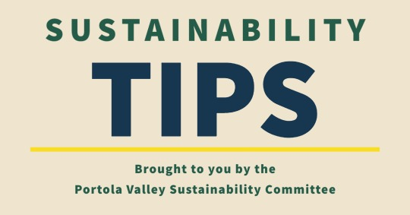

# **Gas Powered Leaf Blowers - You Can Help!**

Gas powered leaf blowers are no longer allowed in the Town as of January 2021. Yet as we all are aware, there are many gardeners who continue to use gas powered blowers. The main reason that I have discovered in speaking with a number of gardeners is the significant cost of switching to a battery powered blower. One of the preferred brands of gardeners is Stihl and these units with portable battery packs can cost over $1000. There are also less expensive options available from other manufacturers in the $250 - $400 range.  
  
Happily, the State of California has a voucher program that will offset up to 70% of the cost of purchasing battery powered blowers for our gardeners to use. The details for this program can be found at the following site: <https://californiacore.org/how-to-participate-professional-landscape/>  
Flyers are available in multiple languages.

Here is how the program works:  
A landscaper/gardener chooses a blower/battery combination from the list of approved products and contacts a CORE approved dealer. A voucher form is submitted by the dealer. Once the voucher is approved (which can take up to two months) and applied to the total cost, the landscaper/gardener can pick up the battery powered blower from the dealer and pay the remaining balance - which is typically 30% of the MSRP. This is a very substantial financial incentive!

Currently there is $16.6 million in remaining funding for this program. Two local businesses participating in the program include Los Altos Hardware and Ewing Irrigation in San Carlos. Portola Valley Hardware does not currently participate.  
  
For those of you who have gardeners still using gas powered blowers, PLEASE help your gardener participate in this program. It is a straightforward and relatively simple way to eliminate gas powered blowers from the Town. If your gardener takes care of multiple properties in Portola Valley, the cost could potentially be spread among those homeowners, making it even more affordable.