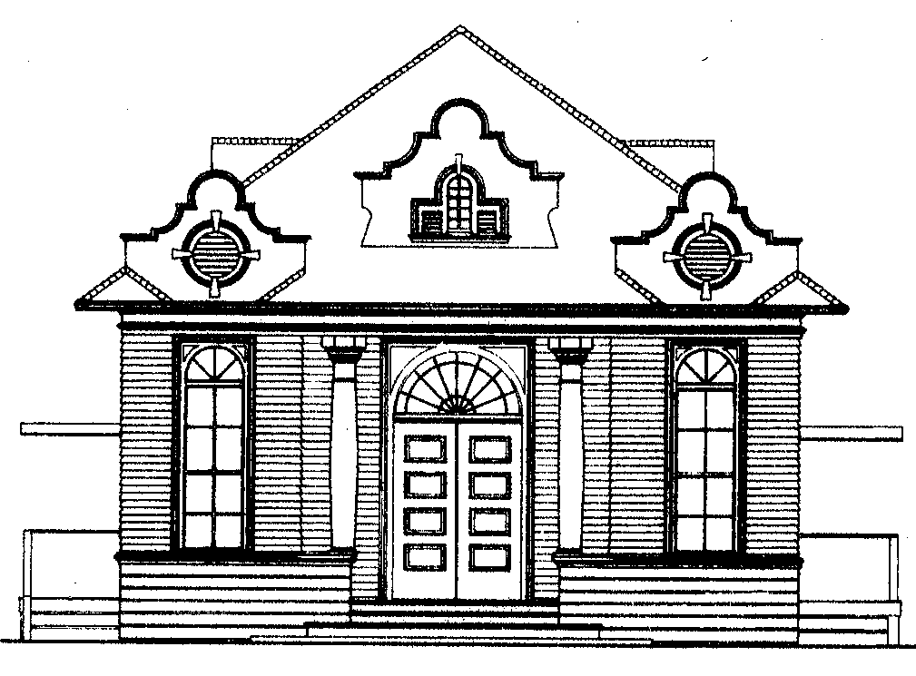

TOWN OF PORTOLA VALLEY
7:00 PM – Regular Town Council Meeting
Wednesday, June 28, 2023
Historic Schoolhouse/Zoom
765 Portola Road, Portola Valley, CA 94028

NOTICE OF MEETING CANCELLATION

REGULAR MEETING OF THE PORTOLA VALLEY
TOWN COUNCIL SCHEDULED FOR
Wednesday, June 28, 2023

Notice is hereby given that the Regular Meeting of the Portola Valley Town Council scheduled for Wednesday, June 28, 2023, has been canceled. The next regular meeting of the Portola Valley Town Council is scheduled for Wednesday, July 12, 2023.

